SELECT * FROM FACILITY;
INSERT INTO FACILITY (FACNO, FACNAME) VALYES (‘F104’, ’SWIMMING POOL’);
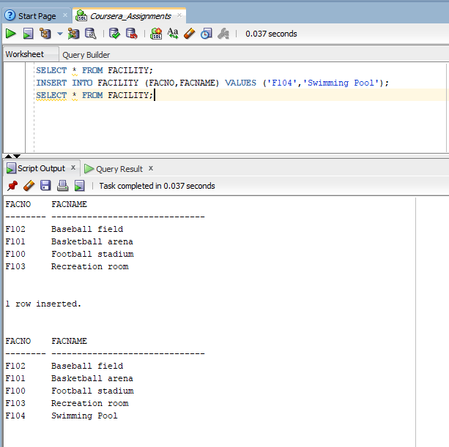
SELECT * FROM FACILITY;

